Library App

Kekoa Kubli

CST-452 Capstone Project Requirements Document

Grand Canyon University

Instructor: Professor Donna Jackson

Revision: 1.0

Date: September 3, 2023

**ABSTRACT**

The Books application is a library book management application. Using basic CRUD operations Users will be able to manage books that are available within a library. This application will be to allow users to add books to the libraries inventory, get a list of books based on different search criteria, and remove books from the inventory when books are checked out. The goal of this application is to help libraries maintain its inventory and to allow users to see what book are available.

|  |
| --- |
| History and Signoff Sheet |

**Change Record**

|  |  |  |
| --- | --- | --- |
| **Date** | **Author** | **Revision Notes** |
| 7/25/2023 | Kekoa Kubli | Initial draft for review/discussion |
|  |  |  |
|  |  |  |

|  |
| --- |
| **Overall Instructor Feedback/Comments** |

|  |
| --- |
| **Overall Instructor Feedback/Comments** |

**Integrated Instructor Feedback into Project Documentation**

Yes  No

**TABLE OF CONTENTS**

Functional Requirements 4

Non-Functional Requirements 5

Technical Requirements 6

Logical System Design 7

User Interface Design 8

Reports Design 9

Functional Requirements

**Use Cases**

Describe the sequence of functional actions a project performs with either textual Use Cases, UML Use Case diagrams, or if using Scrum, provide a link to the User Stories (see template included in course materials).

NOTE: Once the functional requirements have been completed, there may be situations where Use Cases or User Stories may need to be taken out of scope, possibly due to technical challenges or timeline challenges. Any Use Cases or User Stories that are taken out of scope once the project development has started must be approved by the mentor and instructor with justification as to why the functionality is being removed from the project. The following must be updated if any Use Cases or User Stories are taken out of scope:

|  |  |  |
| --- | --- | --- |
| **Use Case or User Story** | **Approval Date** | **Justification** |
| **As a user I want to be able to add a book to the database to be stored for later usage.** | **7/27/2023** | **User must be able to fill out requirements of a form and submit to API to be added to the database.** |
| **As a user I want to be able to search for books in the database based on different criteria so that I can find the exact book that fits my interests.** | **7/27/2023** | **User must be able to select the criteria of a search and be able to find all book that fit the filter information.** |
| **As a user I want to be able to update a books information in the database so that mistakes and typos can be adjusted.** | **7/27/2023** | **User can view information in a form layout and make changes. From there the submission is sent to update the database table** |
| **As a user I want to be able to remove books from the database so that we can keep current inventory for other users to search.** | **7/27/2023** | **User should be able to click a delete button to remove the book from being available.** |

Non-Functional Requirements

**Use Cases**

Describe the sequence of non-functional actions a project performs with either textual Use Cases, UML Use Case diagrams, or if using Scrum, provide a link to the User Stories (see template included in course materials).

NOTE: Once the non-functional requirements have been completed, there may be situations where Use Cases or User Stories may need to be taken out of scope, possibly due to technical challenges or timeline challenges. Any Use Cases or User Stories that are taken out of scope once the project development has started must be approved by the mentor and instructor with justification as to why the functionality is being removed from the project. The following must be updated if any Use Cases or User Stories are taken out of scope:

|  |  |  |
| --- | --- | --- |
| **Use Case or User Story** | **Approval Date** | **Justification** |
| **As a user I want my database to be deployed to the cloud so that is accessible from more then just one computer** | **7/27/2023** | **Database should be deployed on a cloud platform to be accessed from anywhere.** |

Technical Requirements

**Use Cases**

Describe the tools and technologies used in the project.

NOTE: Once the technical requirements have been completed, there may be situations where technologies or tools may need to be taken out of scope or changed, possibly due to technical challenges or timeline challenges. Any technologies or tools that are taken out of scope or changed once the project development has started must be approved by the mentor and instructor with justification as to why the functionality is being removed from the project. The following must be updated if any technologies or tools are taken out of scope or changed:

|  |  |  |
| --- | --- | --- |
| **Technology or Tool** | **Approval Date** | **Justification** |
| **React.JS Framework** | **7/27/2023** | **To build out Front-end components for quick page load times** |
| **Azure/AWS cloud database** | **7/27/2023** | **To have global access to library database.** |

Logical System Design

Provide a diagram of the logical architecture of the system.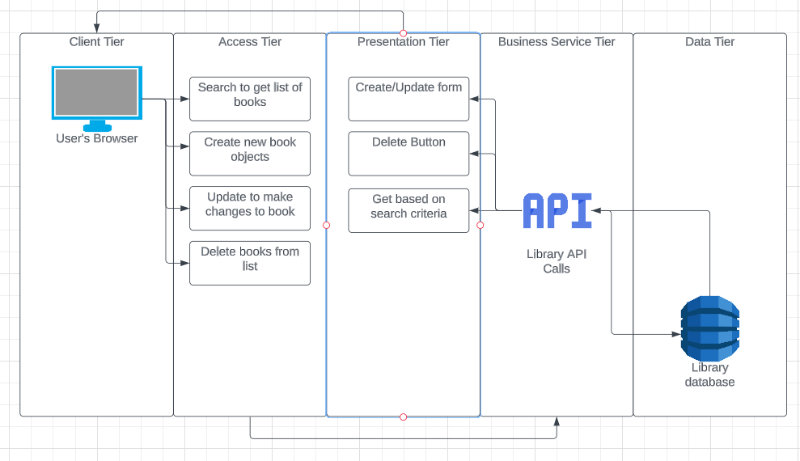

User Interface Design

Provide a sitemap and user interface design diagram for each user interface screen in the application, if not applicable, define the components of the project as described in the handbook. A screenshot of a computer

Reports Design

Provide a listing of the reports that the system will provide, if applicable. If not, state that the system does not produce any reports and provide additional documentation as described in the handbook.